Washington Volunteer Fire & Rescue
Kids Fire Camp June 15th or 16th 2018
This is a very fun, exciting and free camp!
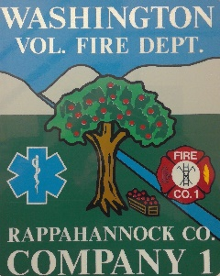
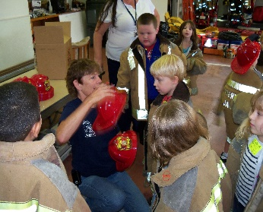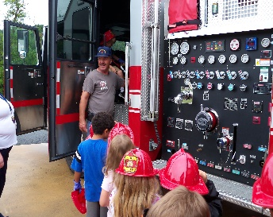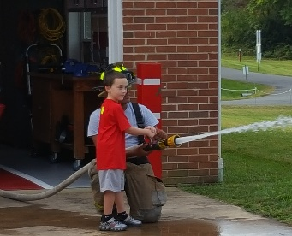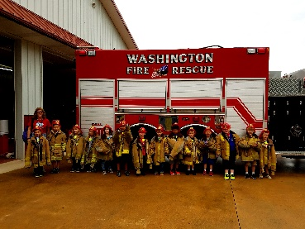
- Fire Camp is a fun and exciting day learning about the role of a firefighter.
- Fire Camp teaches Firefighting, Rescue Practices, and First Aid.
- Fire Camp is about challenging yourself, teamwork, and making friends.
Fire Camp is open to 3rd through 7th graders day one and 8th through 12th graders day two
Please submit applications by May 23rd, 2018.
Applications can be submitted in person at the station, emailed or mailed.
Washington Volunteer Fire & Rescue
PO Box 238 Washington, VA 22747
Wvfr1@comcast.net (540)675-3615
Additional camp details will be supplied via email once registered.
Application Please Type or Print Legibly
Child’s Name_____________________ Birthday__________ Allergies__________
Grade for 2018-2019 school year______ Parent/Guardian Contact number _______________
Parent’s Email address: ____________________________________
Child’s Home Address: ___________________________________________________________
Emergency contact name and number___________________________________
Parent/Guardian Name Print____________________ Signature___________________
These Materials and the activity described herein are not sponsored or endorsed by Rappahannock County Schools.

