Washington Volunteer Fire & Rescue
Fire Camp July 13th 2019
This is a very fun, exciting and free camp!
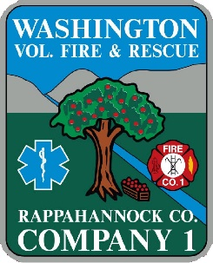
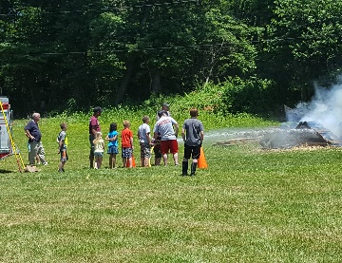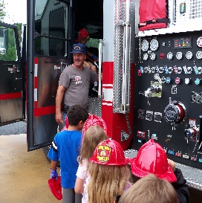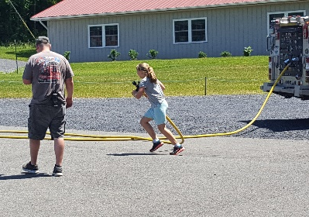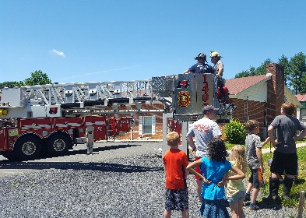
- Fire Camp is a fun and exciting day learning about the role of a firefighter.
- Fire Camp teaches Firefighting, Rescue Practices, and First Aid.
- Fire Camp is about challenging yourself, teamwork, and making friends.
- Fire Camp will be held July 13th from 9am to 4pm
Fire Camp is open to all Rappahannock County students grades 3 through 12
Applications can be submitted in person at the station or emailed.
Washington Volunteer Fire & Rescue
10 Firehouse Lane Washington, VA 22747
Wvfr1@comcast.net (540)675-3615
Child’s Name_____________________ Birthday__________ Allergies__________
Grade for 2019-2020 school year______ Parent/Guardian Contact number _______________
Parent’s Email address: ____________________________________
Child’s Home Address: ___________________________________________________________
Emergency contact name and number___________________________________
Parent/Guardian Name Print____________________ Signature___________________
These Materials and the activity described herein are not sponsored or endorsed by Rappahannock County Schools.
Please submit entry forms by July 1st

